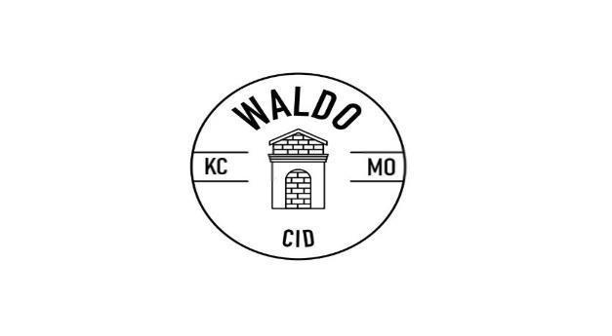
Waldo CID Storefront Improvement Grant

Powered by the Waldo Community Improvement District
7222 Wornall Rd., Kansas City, MO 64114
816-286-4523 • fax 816-569-9460 • www.waldokc.org
Helping you improve your business and Waldo!
Good-looking, well-maintained buildings help ensure Waldo remains a great place to do business. To encourage improvements and repairs, the Waldo CID created the Storefront Improvement Grant. The grant supports local businesses and property owners through funding a portion of exterior building repairs and improvements that meet program requirements.

The “Nuts & Bolts”

Funds: Applications are accepted annually. Grants are awarded on a first-come, first-served basis until all budgeted grant money is allocated. Applications will be reimbursed at half the approved project cost, with the Waldo CID's share not to exceed $7,500 per project. The Waldo CID funds and oversees, and the WABA Property Committee administers the program.

Requirements:
- Properties must be occupied or under contract (no speculative improvements) and must be located within the Waldo CID boundaries to be eligible.
- The business must maintain a valid Occupational License with the City of Kansas City throughout the project.
- Grant applications may be submitted by either a business or property owner, but must be signed as authorized by the property owner.
- Funds may only be used for eligible expenses approved in writing. Funds cannot be used for previously completed improvements (work started prior to approval is ineligible).
- Projects must meet all applicable City Zoning, Sign and Building Code requirements.
- Only one rebate is allowed per “building” (determined by roofline) every 10-years.
- Information below is required with completed application including:
  - A completed and signed application form o Bids for work to be completed
  - IRS Form W-9
  - “Before” photos showing existing conditions
  - Supporting materials (drawings, presentations, etc.)
Process:
- Contact Sean Anderson (sean@waldokc.org), at the Waldo CID, to schedule a pre-application meeting to discuss the project, process and requirements.
- Give a formal presentation to the WABA Property Committee. Following consideration, the Committee may request additional information. Applicants will be notified of approval, approval with conditions, or denial in writing.
- Complete the work within 180 days after approval and notice to proceed (unless an extension is previously requested and approved by the WABA Property Committee).
- Submit the following upon completion of the project:
  - Verification all work has been completed and conditions met
  - All receipts for completed work, and proof of payment (canceled checks, verification from contractor amount due is paid in full, or similar)
  - “After” photos showing the changes and completed project
- Once all requirements have been met, the Waldo CID will reimburse the applicant (unless otherwise specified) within 2 weeks of receiving all required documentation.

Objectives:
The primary program objectives are to serve as a catalyst for improvements, help ensure long-term building care, and to achieve long-lasting changes and improvements. As the name “Storefront” implies, the Waldo CID intends for the funds to generally be used for visible improvements. Although improvements to other portions of the building may be eligible and allowed, they should be secondary and not the focus of the application.

Following are lists of eligible and ineligible improvements. Since some eligible improvements may not directly meet these objectives, the Waldo CID and the WABA Property Committee may use discretion in approving or denying all or portions of applications based on the ability to meet program objectives. The Waldo CID and the WABA Property Committee may also apply additional restrictions, requirements and conditions as deemed necessary and appropriate to achieve program objectives.

Eligible Expenses:
- Removing and/or replacing siding or facades
- Patching concrete
- Fixing or replacing handrails
- Repairing or installing gutter and downspout systems in conjunction with other facade improvements
- Tuck pointing brick and masonry
- Security system improvements, including cameras, alarm systems, and windows. *Security cameras must be installed according to CID guidelines.
- Repairing or replacing cornices, trim, or architectural details
- Repairing or replacing windows (high insulation values are encouraged)
- Painting or cleaning exterior
- Adding approved, architecturally interesting, features or repairing existing architectural features
- Installing, repairing or replacing appropriate awning or signage
- Installing or replacing exterior lighting
- Improving streetscape and landscape (as part of the project)
- Repairing/replacing parking lots, driveways, sidewalks (as part of a larger project) ✓ Replacing doors
- Decorative fencing (such as wrought iron fencing, excludes barbed-wire or razor-wire) ✓ Materials
- Contracted labor

Non-Eligible Expenses:
- Interior work
- Electrical improvements (excluding exterior lighting)
- HVAC improvements
- Property acquisition
- Equipment, Furniture, and Fixtures
- Roofs
- In-house labor by property owner, tenant, or employees
- Other work determined not meet program objectives

Additional information:

Waldo CID
Sean Anderson
7222 Wornall Rd
Kansas City, MO 64114
(816) 286-4523/ (816) 569-9460 fax
Sean@waldokc.org

SEE BELOW FOR APPLICATION**

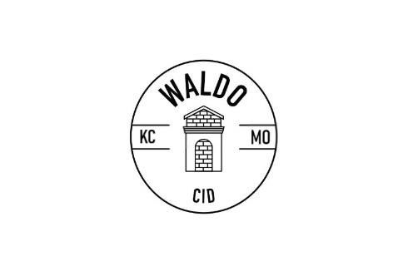
Waldo CID Storefront Improvement Grant

Powered by the Waldo Community Improvement District
7222 Wornall Rd., Kansas City, MO 64114
816-286-4523• fax 816- • www.waldokc.org

Application

Please fill out the following information and return the completed form with all required attachments to the Waldo CID at the address below. Feel free to attach additional documents if needed.

1. Owner/Applicant Information

Applicant: ________________________ Property Owner: _______________________
Title: ____________________________ Title: ________________________________
Address: _________________________ Address: _____________________________
________________________________ ____________________________________
Phone: ___________________________ Phone: _______________________________
Email: ___________________________ Email: _______________________________

Business Name: ___________________________________________________________

Project Address: _____________________________________________

2. Project Information

Project description (describe the proposed improvements, repairs, changes): __________
_______________________________________________________________________
_______________________________________________________________________
_______________________________________________________________________
_______________________________________________________________________
_______________________________________________________________________
_______________________________________________________________________ _______________________________________________________________________

3. Required signatures

Applicant: ______________________________________________ Date: __________

Property Owner: _________________________________________ Date: __________

I (we) authorize submittal of this application and certify all information provided is true and correct, hereby acknowledge understanding of grant guidelines and agree to the stipulations of the program, and authorize use of before and after photos, drawings and other materials by the Waldo CID to promote the CID and grant program.
Thank you for your application

For Office Use Only
Application accepted as complete by: _________________________________________________________
Date: __________________________________________________________________________________
Action taken: ❑ Approved ❑ Approved with Conditions ❑ Denied
Date: _______________________________ Date Notified: _________________________ Notes:

Waldo CID Storefront Improvement Grant

Powered by the Waldo Community Improvement District
7222 Wornall Rd., Kansas City, MO 64114
816-286-4523• fax 816-569-9460 • www.waldokc.org

Request for Reimbursement

Upon completion of the approved project, please provide the following information and return the completed form and required attachments to the Waldo CID at the address below. Feel free to attach additional documents as needed.

Address: _______________________________________________________________
Business Name: __________________________________________________________
Person completing the report: ______________________________________________
Address: _______________________________________________________________
______________________________________________________________________
Phone: ___________________________ Email: _____________________________
Name for rebate check (if different from business): _____________________________
Address (if different from above): ___________________________________________
Has all work been completed and all conditions met? Please describe: ______________
______________________________________________________________________
______________________________________________________________________ ______________________________________________________________________

Required attachments:
- Verification all work has been completed and conditions met
- All receipts for completed work, and proof of payment (canceled checks, verification from contractor amount due is paid in full, or similar)
- “After” photos showing the changes and completed project

Signature: ______________________________________________ Date: __________

I certify all information provided is true and correct, and authorize use of before and after photos, drawings and other materials by the Waldo CID to promote the CID and grant program.

